NRT Provision:
The provision of NRT via a voucher scheme/letter of recommendation is a non-contractual element of the Public Health contract and therefore community pharmacies may not hold a contract to provide a L2 stop smoking service but can continue to provide NRT to clients who present with a valid NRT voucher code.

If you are delivering a L2 service you do not need to use the NRT voucher processing template for your clients as this will be done via templates 1 and 2, but you will need to use this template if someone is receiving treatment elsewhere but presents at your pharmacy with a valid voucher code.

When a client presents at the pharmacy with a NRT voucher code you will need to log onto PharmOutcomes and use the NRT voucher processing template to process the voucher. When you log in to PharmOutcomes the link below will appear on the left hand side on the services tab.

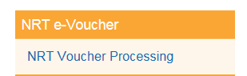

The following screen will appear:
Enter your voucher code.
PLEASE NOTE if you have provided the code for your patient the screen will appear as below.

***ANY VOUCHER CODE SUPPLIED BY HHIS WILL SAY “RECORDED BY ANOTHER PROVIDER” – this is simply highlighting that the voucher code was issued by another provider and does not mean it has already been redeemed.*** Please see below for info on recognising if a voucher has already been redeemed.
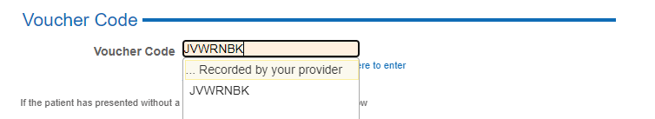
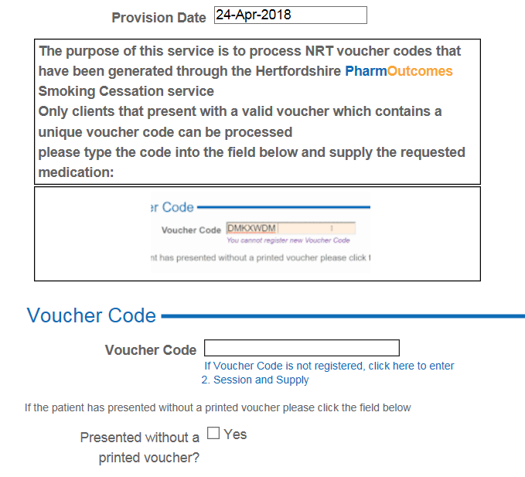
Once you have entered the voucher code you will see the details of the session and NRT supply required on the left hand side in the clients provision history;

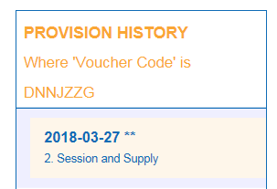
Please fill in the boxes as required on the templates and provide the NRT as requested. Once saved this will automatically generate a claim for your pharmacy on a quarterly basis, including the appropriate handling fee and deducting any prescription fees collected.

If you view the provision history and you can see ‘NRT voucher processing’ this means the voucher has already been issued by another provider. If you click on it, you will be able to see the details of the supply.
