


Community Pharmacy PCN Engagement Lead Toolkit
Introduction
This toolkit is designed to support Community Pharmacy PCN Engagement Leads across Hertfordshire and West Essex. It provides key contacts, guidance, and tools to help you:
- Represent community pharmacy in PCN discussions
- Strengthen relationships with local partners
- Support the rollout of Pharmacy First, BP Checks, and Contraception services
- Share updates, resolve issues, and highlight progress
It is a practical resource to help you lead locally and integrate pharmacy into wider care pathways.
Note: Contractual or regulatory issues (e.g. opening hours, complaints) should be escalated to your Community Pharmacy Local (CPH or CPEsx)

Community Pharmacy PCN Engagement Lead – Role Overview
Engagement Leads act as key connectors between community pharmacies and Primary Care Networks (PCNs), helping to foster integrated clinical pathways and strengthen collaborative relationships. They serve as the central link between pharmacy teams and PCN leadership, supporting the ongoing implementation of nationally commissioned services, such as Pharmacy First, Blood Pressure Checks, and Contraception, and ensuring these services are effectively embedded and optimised across the local healthcare system.
Further information is available on the HWE Training Hub website, including contact details for other CP PCN Engagement Leads across HWE.

Finding Local Information
Access the list of community pharmacies and GP surgeries in each PCN here. *Note: The phone number of the community pharmacies is available on the NHS website.

Expectations of the Community Pharmacy PCN Engagement Lead
As a Community Pharmacy PCN Engagement Lead, you are expected to:
- Represent Community Pharmacy Locally
- Attend and contribute to relevant PCN and locality-level meetings (e.g. clinical director meetings, neighbourhood team meetings).
- Ensure the voice of community pharmacy is included in discussions and decision-making.
- Act as a liaison between the ICB, LPC, GP practices, and local pharmacies.
- Support Implementation of Services
- Support the roll-out and local delivery of Pharmacy First, Blood Pressure Checks, and Contraception services.
- Help develop or adapt SOPs and referral protocols with PCNs to ensure smooth integration of pharmacy services.
- Strengthen Relationships Across the PCN
- Build and maintain positive working relationships with:
  - PCN Clinical Directors and GP practices
  - Local NHS colleagues
  - Other pharmacy leads across the area
- Encourage collaboration and mutual understanding between pharmacy and general practice.
- Communicate and Coordinate with Contractors
- Keep pharmacies informed of relevant PCN updates, priorities, and decisions.
- Proactively gather insight and feedback from contractors.
- Share relevant learning, best practice, and service updates from the ICB, PCN, or LPC.
- Let pharmacies know when you’re attending meetings and feed back key outcomes to ensure transparency.
- Drive Local Transformation
- Contribute to local PCN strategies and transformation plans, ensuring pharmacy is involved.
- Work to align clinical pathways and integrated care models with pharmacy services.
- Champion pharmacy’s role in tackling inequalities and improving patient access.
- Be a Leadership Presence
- Act as a leader and advocate for community pharmacy at place and system level.
- Take part in development opportunities, such as training, leadership forums, and collaboration events.
- Share ideas, challenges, and progress with other PCN Leads, the ICB, and LPC.
- Maintain Professional Standards
- Ensure community pharmacy remains a trusted and professional part of the system.
- Be mindful of confidentiality, patient safety, and governance when sharing feedback or raising issues.
- Declare any conflicts of interest and act in the best interests of patients and the wider health system.

Role Expectations & Key Actions
As a Community Pharmacy PCN Engagement Lead, your role over the coming months is to build strong relationships, support service improvement, and demonstrate the value of community pharmacy within the local system. The following short- and medium-term expectations are designed to help you contribute to both the strategic integration of pharmacy and the practical delivery of services within your PCN.
Immediate Focus: Next 2–3 Months
1. Drive Local Action & Collaboration
- Share locally developed SOPs and referral processes with fellow CP PCN Leads to support wider learning and replication.
- Lead or contribute to stakeholder engagement with GP practices, INTs, ICB teams, and schools to promote pharmacy services.
2. NHS 111 Inappropriate Referrals
- Use the CPH-provided template to collect evidence of inappropriate NHS 111 referrals between 16 June and 14 July.
3. Set and Deliver Personal Actions
Each lead should define and pursue local priorities, which may include:
- Promoting community pharmacy in Integrated Neighbourhood Teams (INTs)
- Extracting and using Excel-based service data to inform PCN discussions
- Exploring AccuRx or other tools to strengthen two-way communication with GP practices
- Reviewing NMS and SMR data to support structured medication reviews (e.g., depression reviews)
- Strengthening ties with Clinical Directors and attending relevant PCN meetings
- Improving stakeholder engagement across pharmacies, GPs, and system partners

Medium-Term Focus: 6–9 Months
1. Demonstrate Impact and Value
- Collect and report examples of how your work is improving collaboration, communication, and service delivery across the PCN.
- Submit regular updates via the PCN Leads reporting form to help build a system-wide picture of progress.
2. Key Outcomes to Work Towards
- Improve Service Uptake:
  - Boost Pharmacy First referral volumes
  - Address service blockers (e.g., low uptake of BP or contraception services, IT barriers)
  - Improve delivery of services such as depression reviews within NMS and SMRs
- Enhance Relationships & Feedback Loops:
  - Improve two-way communication between pharmacies and GPs
  - Establish feedback mechanisms (e.g., WhatsApp groups, meeting follow-ups)
  - Close the loop with contractors on issues raised and resolved

Contacting for Support
Ensure you know the right contacts for support within your Community Pharmacy Local and the HWE ICB. For routine matters and common challenges, begin by reaching out to your local pharmacy contacts who are familiar with your specific context. For specialised or more complex issues, be prepared to escalate appropriately to secure timely and effective solutions. If you’re ever uncertain about the best approach, don’t hesitate to ask for advice.

Primary Care Directorate

ENH place | Cathy Galione - Head of Primary Care Transformation, Integration, Development & Delivery – East & North Hertfordshire - cathy.galione@nhs.net  Penny Thomas - Senior Primary Care Manager, Transformation, Integration, Development & Delivery – East & North Hertfordshire - penny.thomas@nhs.net  Michelle Hicks - Senior Primary Care Manager for Transformation, Integration, Development & Delivery - East & North Herts michelle.hicks1@nhs.net
SWH place | Melanie Powell, Head of Primary Care Transformation and Integration (SWH) – melanie.powell9@nhs.net  Amanda Burfot, Senior Primary Care Manager for Transformation, Integration and Delivery (SWH) - amanda.burfot@nhs.net  Liz Cox, Senior Transformation, Integration Development Delivery Manager - liz.cox7@nhs.net
West Essex | Philip Sweeney, Head of Primary Care Transformation and Integration - West Essex philip.sweeney2@nhs.net  Josephine Smit, Senior Primary Care Manager for Transformation, Integration and Delivery – West Essex - josephine.smit@nhs.net  Renate Scheffer, Primary Care Manager - r.scheffer@nhs.net

Pharmacy and Medicines Optimisation Team (PMOT)
SURNAME | FIRST NAME | Locality | Email address
East and North Herts
Parikh | Sima | Lead Pharmaceutical Advisor | hweicbhv.medicinesoptimisationteam@nhs.net
Shah | Niraj | WelHat | hweicbhv.medicinesoptimisationteam@nhs.net
Tatla | Shikha | Lower Lea Valley | hweicbhv.medicinesoptimisationteam@nhs.net
Shah | Niraj | Upper Lea Valley (Ware and Rurals PCN and Hoddesdon and Broxbourne PCN) | hweicbhv.medicinesoptimisationteam@nhs.net
Abed | Zainab | Upper Lea Valley (Hertford and Rurals PCN) | hweicbhv.medicinesoptimisationteam@nhs.net
Abed | Zainab | North Herts | hweicbhv.medicinesoptimisationteam@nhs.net
Shah | Chirag | Stort Valley and Villages | hweicbhv.medicinesoptimisationteam@nhs.net
Shah | Chirag | Stevenage | hweicbhv.medicinesoptimisationteam@nhs.net
South and West Herts
Jackson | Alison | Lead Pharmaceutical Advisor | hweicbhv.medicinesoptimisationteam@nhs.net
Tailor | Misha | Watford and Three Rivers | hweicbhv.medicinesoptimisationteam@nhs.net
Khakoo | Jamil | St Albans and Harpenden | hweicbhv.medicinesoptimisationteam@nhs.net
Rashid | Mehmood | Hertsmere | hweicbhv.medicinesoptimisationteam@nhs.net
Kruti | Shah | Dacorum | hweicbhv.medicinesoptimisationteam@nhs.net
West Essex
Kotecha | Radhika | Lead Pharmaceutical Advisor | hweicbhv.medicinesoptimisationteam@nhs.net
Gita | Ghai | Harlow | hweicbhv.medicinesoptimisationteam@nhs.net
Tatla | Shikha | North Uttlesford | hweicbhv.medicinesoptimisationteam@nhs.net
Gita | Ghai | South Uttlesford | hweicbhv.medicinesoptimisationteam@nhs.net
Ashik | Shah | Epping | hweicbhv.medicinesoptimisationteam@nhs.net

Primary Care Locality leads

Note: If your relationship with the GP Clinical Lead could benefit from a refresh or stronger connection, it is recommended that you arrange a meeting with them, ideally alongside your Place Lead or Manager.
Role | ICB/Place/Locality | Name | Email
Primary Care Locality GP Clinical leads – SWH | Dacorum | Dr Pani Sissou | panisissou@nhs.net
Primary Care Locality GP Clinical leads – SWH | Watford & Three Rivers | Dr Asif Faizy | Asif.faizy@nhs.net
Primary Care Locality GP Clinical leads – SWH | Hertsmere | Dr Kate Page (Lead)  Dr Liam Chapman (support) | Catherine.page2@nhs.net  Liam.chapman2@nhs.net
Primary Care Locality GP Clinical leads – SWH | St Albans | Dr Bethan Rees | brees@nhs.net
Primary Care Locality GP Clinical leads – ENH | Lower Lea Valley | Dr Alison Jackson | alisonjackson@nhs.net
Primary Care Locality GP Clinical leads – ENH | Stevenage | Dr Kolade Daodu | Kolade.daodu@nhs.net
Primary Care Locality GP Clinical leads – ENH | Stort Valley & Villages | Dr Sarah Dixon | sarah.dixon1@nhs.net
Primary Care Locality GP Clinical leads – ENH | North Herts | Dr Tara Belcher | Tara.belcher@nhs.net
Primary Care Locality GP Clinical leads – ENH | Upper Lea Valley | Dr Jay Kuruvatti | jaykuruvatti@nhs.net
Primary Care Locality GP Clinical leads – ENH | Welwyn & Hatfield | Dr Ashish Shah | Ashish.shah5@nhs.net
Primary Care Locality GP Leads – WE | Harlow | Dr Michael Napal-David | Michael.napal-david1@nhs.net
Primary Care Locality GP Leads – WE | Epping | Dr Stephen Rebel | stephenrebel@nhs.net
Primary Care Locality GP Leads – WE | Uttlesford | Dr Richard Boyce | richard.boyce2@nhs.net

Primary Care Clinical leads
East and North Herts
PCN | PCN clinical lead | Email
Broxbourne Alliance | Alison Jackson | alisonjackson@nhs.net
Lea Valley Health | Pearl Onyekuru | ponyekuru@nhs.net
Hitchin & Whitwell | Tara Belcher | tara.belcher@nhs.net
Icknield | Adrian Wood | woodap@nhs.net
Stevenage North | Prag Moodley | prag.moodley@nhs.net
Stevenage South | Kolade Daodu | kolade.daodu@nhs.net
Stort Valley & villages | Sian Stanley | sianstanley@nhs.net
Hertford & Rurals | Giles Pratt | giles.pratt@nhs.net
Hoddesdon & Broxbourne | Rob Mayson | rmayson@nhs.net
Ware & Rurals | Fin O'Reilly | fingal.o_reilly@nhs.net
Hatfield | Jennifer Barrett | jennifer.barrett1@nhs.net
Welwyn Garden City | Tom Gillham | t.gillham@nhs.net
South and West Herts
PCN | PCN clinical lead | Email
Alliance | Dr Kapil Kedia & Dr Khalid Mirza | kapilkedia@yahoo.com
Alliance | Dr Kapil Kedia & Dr Khalid Mirza | kapil.kedia1@nhs.net
Alliance | Dr Kapil Kedia & Dr Khalid Mirza | khalid.mirza@nhs.net
Alpha | Dr Pani Sissou | panisissou@nhs.net
Beta | Eleanor Williams | eleanorwilliams2@nhs.net
Delta | Dr Seraj Anwer | serajanwer@nhs.net
Potters Bar | Dr Anup Shah | anup.shah@nhs.net
Herts Five | Dr Liam Chapman | liam.chapman2@nhs.net
Abbey Health | Dr Helen Mcandrew | helen.mcandrew2@nhs.net
Alban Healthcare | Dr Bruce Covell | brucecovell@nhs.net
Harpenden Health | Dr Bethan Rees | brees@nhs.net
HaLo | Dr Sarah Dowling & Dr Julia Morgan | sdowling@nhs.net  juliamorgan1@nhs.net hweicbhv.halo.cd@nhs.net
Central Watford | Dr Daljit Singh Khalo | dkhalo@nhs.net
MVPS PCN | Dr Sonal Shah | sonal.shah3@nhs.net
North Watford | Dr Asif Faizy | a.faizy@nhs.net
Rickmansworth and Chorleywood | Dr Matt Jennings | matthew.jennings3@nhs.net
The Grand Union | Dr Rami Eliad | rami.eliad@nhs.net
Bridgewater | Dr Alex Carefull | alex.carefull@nhs.net
West Essex
PCN | PCN clinical lead | Email
Loughton, Buckhurst Hill and Chigwell | Dr Stephen Rebel | stephenrebel@nhs.net
Loughton, Buckhurst Hill and Chigwell | Dr Lak Larh | llarh@nhs.net
Epping Forest North | Dr Bradley Sanders | bradley.sanders@nhs.net
Harlow North | Dr Bolaji Kuti | bkuti@nhs.net
Harlow North | Dr Felix Kehinde | fkehinde@nhs.net
Harlow South | Dr Jey Selvarajah | jselvarajah@nhs.net
North Uttlesford | Dr Richard Boyce | richard.boyce2@nhs.net
South Uttlesford | Dr Angus Henderson | angus.henderson1@nhs.net
South Uttlesford | Dr Ben Seaman | bseaman@nhs.net

Community Pharmacy Local

For support, queries, or to connect with the LPC team, please contact:
Community Pharmacy Hertfordshire (CPH)  For Hertfordshire-related queries, please contact  - Niru Sivanesan 07485 327355 niru.sivanesan@cpherts.org.uk  Leads and supports PCN leads | Community Pharmacy Essex (CPEsx)  For Essex-related queries, please contact:  - Karen Samuel-Smith  karen@cpesx.org.uk  Leads and supports PCN leads

WhatsApp Groups for PCN Pharmacy Leads
These groups are here to support your role, encourage collaboration, and enable shared learning and communication across the system:
- Hertfordshire CP PCN Engagement Leads Support Group (Private – for direct communication with the LPC and other CP PCN Engagement Lead colleagues)
A confidential space for sensitive conversations, including issues that may require LPC input before being raised more widely. Use this group to raise concerns, ask questions, and receive direct support from the LPC.
- HWE PCN CP Engagement Leads Group (Broader group – for system-wide collaboration and peer support)
This group includes HWE system colleagues and provides a space to share best practice, raise concerns pharmacies may have, and collaborate to find solutions across PCNs.
If you need to be added to either group, please contact Niru Sivanesan.

Meetings

Please let the relevant CPL or ICB colleague aware if you require meeting invites for the below.
ENH  Cathy Galione | PCN Managerial Leads Meeting (2-monthly)  all 10:00 am on Teams 9th September, 11th November, 13th January, 17th March  Practice managers meetings  all 10:30 on Teams: 15th July, 19th August, 16th September, 21st October, 18th November, 16th December, 20th January, 18th February, 17th March  Local neighbourhood team meetings / INCB meetings Details found on page 8
SWH  Melanie Powell/Amanda Burfot | SWH HCP Transformation meeting  Watford Delivery Group  Hertsmere Delivery Group  Dacorum Locality Forum  St. Albans Locality Forum
West Essex  Philip Sweeney | Clinical director meetings with the GP practices  PAH UTC meeting(s)  West Essex weekly meetings at Kao Park

ENH Local neighbourhood team meetings / INCB meetings
Meeting Type | Chair(s) | ICB Rep | Jul-25 | Aug-25 | Sep-25 | Oct-25 | Nov-25 | Dec-25 | Jan-26 | Feb-26 | Mar-26
Stort Valley & Villages INCB | Sarah Dixon | Monica & David |  |  | 04-Sep |  |  | 04-Dec |  |  | 05-Mar
Upper Lea Valley INCB | Rob Mayson | Monica & David | 23-Jul |  | 30-Sep |  | 26-Nov |  | 20-Jan |  | 18-Mar
Upper Lea Valley INCB | Jay Kuruvatti
Lower Lea Valley INCB | Alison Jackson | Tony Deitsch | 30-Jul | 27-Aug | 24-Sep | 29-Oct | 26-Nov | 17-Dec | 28-Jan | 25-Feb | 25-Mar
North Herts INCB | Tara Belcher | Tony Deitsch | 03-Jul |  | 04-Sep | TBC | TBC | TBC | TBC | TBC | TBC
Stevenage INCB | Provider Rota | Vikki & Kathryn | 22-Jul |  | 23-Sep |  | 25-Nov |  | 27-Jan |  | 24-Mar
Stevenage INCB - Subgroup (Operational planning meeting) | Prag Moodley & Kolade Daodu | Vikki & Kathryn |  | 26-Aug |  | 28-Oct |  | 23-Dec |  | 24-Feb
Welhat INCB | Ashish Shah & Tom Gillham | Vikki & Kathryn | 24-Jul |  |  | 23-Oct |  |  | 22-Jan |  | 26-Mar
Welhat INCB - Subgroup (Operational planning meeting) | Ashish Shah | Vikki & Kathryn |  |  | 25-Sep |  | 27-Nov |  |  | 26-Feb

Why These Meetings Are Important
Attending these meetings ensures that community pharmacy has a strong and consistent voice within the PCN and local health systems. As representatives, it’s your opportunity to:
- Raise and resolve issues affecting community pharmacy within the PCN
- Ensure community pharmacy perspectives are included in important discussions and decisions
- Foster collaboration between pharmacies, GP practices, and other healthcare partners
To maintain effective communication, please inform your pharmacies in advance about which meetings you will attend and the topics up for discussion. Encourage them to share any concerns or points they want raised. After the meeting, provide feedback and share any relevant updates with the pharmacies to keep everyone informed and ensure the loop is closed.

Boost Your Pharmacy Services: Data, Resources & Feedback
This section provides the essential tools and information you need to understand, monitor and enhance community pharmacy services within your area.

Accessing Service Data
Access and analyse data on Pharmacy service activity to understand current performance and identify areas for improvement. This data will reveal what services are being provided and highlight areas where engagement can be strengthened.
- The latest community pharmacy data regarding NHS advanced services for HWE ICB is available in files under 'Community Pharmacy Advanced Services Dashboard' via the MS Teams Portal.
- The latest Pharmacy First and CPCS dashboard is available via the MS Teams Portal in the folder "Pharmacy First and CPCS dashboard."

 | What You’re Looking For | Where to Find It
Community pharmacy | BP Checks, ABPM, Contraception | NHS Advanced Clinical Services Dashboard → AdvancedServicesDetail tab (filter by PCN on row 4)
Community pharmacy | 7 Clinical Pathway Consultations | NHS Advanced Clinical Services Dashboard → PharmacyFirst Detail tab
GP Practice | Number of GP referrals to Pharmacy First  (monthly, by GP practice) | Pharmacy First and CPCS Dashboard → ReferralsByGPpractice tab
GP Practice | Cumulative GP referrals to CPCS and Pharmacy First  (cumulative by GP practice) | Pharmacy First and CPCS Dashboard → ReferralsTables-GPcumulative tab
GP Practice | Monthly referrals for the 7 common conditions | Pharmacy First and CPCS Dashboard → 7CC Referrals and 7CommonConditions tabs (use dropdown in cells E1–I1)
Re-referral Information (bouncebacks) | GP referrals to CPCS and Pharmacy First | Pharmacy First and CPCS Dashboard → ReferralsTables-PCN tab
Re-referral Information (bouncebacks) | Consultation outcomes from referrals (incl. re-referrals, escalation) | Pharmacy First and CPCS Dashboard → ConsultationOutcomes, SignpostedTo, and EscalatedTo tabs (PharmOutcomes data only)
NHS 111 | Referrals to community pharmacy from NHS 111 (by GP practice) | Pharmacy First and CPCS Dashboard → ReferralsFrom111 tab

Share Success Stories
As a PCN Pharmacy Lead, your work is central to shaping how pharmacy integrates within primary care and delivers better outcomes for patients. This form is designed to capture your monthly activity, achievements, and the real-world impact of your leadership.
Whether you’ve strengthened relationships across the PCN, supported service delivery, contributed to strategic discussions, or improved communication between pharmacy and general practice — we want to hear about it.
Sharing your experiences helps us:
- Measure the value and outcomes of the PCN Lead role
- Understand what’s working (and where challenges remain)
- Share learning across other areas
- Make the case for continued investment and support

Your insights help us tell the full story of pharmacy leadership — its impact, its value, and its potential. By submitting this short monthly update, you’re helping shape future support, recognition, and investment in the PCN Lead role.

Impact & Story Submission Form
Submit monthly information on what you have achieved and outcomes in your role so we can collect stories on the work you are doing using the Community Pharmacy PCN Engagement Leads Monthly Impact & Story Submission Form

Gathering Patient Feedback
Actively promote the Pharmacy First patient survey to collect valuable insights directly from patients. This feedback is crucial for understanding patient experience and demonstrating impact. Resources to promote the survey can be found on the CPE website.

Strategic Insights for Community Pharmacy Engagement

This section focuses on broader strategic considerations that will help you position community pharmacy effectively within integrated care pathways.
Pharmacies need to be aware of strategic considerations that impact patient care, such as involvement in frailty workstreams and the proper management of dosette boxes for medication adherence.
- Review the feedback from the 16 May leads' meeting on sharing locally developed SOPs and case studies (see appendices), and take forward the key actions identified for the next two months.
- Refer to guidance regarding prescription direction and Medication Collection Arrangements (MCAs).

Empowering Engagement Tools for Leads

These resources are designed to support you in engaging effectively with both GP practices and community pharmacies around key services. Please note: community pharmacy resources are for community pharmacy reference only and should not be shared publicly or directly with GP practices. They are intended to inform your discussions and strengthen your position in engagement conversations. This ensures that pharmacies are supported appropriately and that materials are used to facilitate collaboration, not misinterpreted or used out of context.
For Community Pharmacies Only:
- Maximising Workforce for Revenue Crib Sheet
- Maximising Workforce for Revenue Presentation
For GP Practice Leaders/GP practices and Associated Groups:
- Time Savings for GP practices: Optimising Community Pharmacy Services Crib Sheet
- Time Savings for GP practices: Optimising Community Pharmacy Services Presentation

Appendix 1

Appendix 2
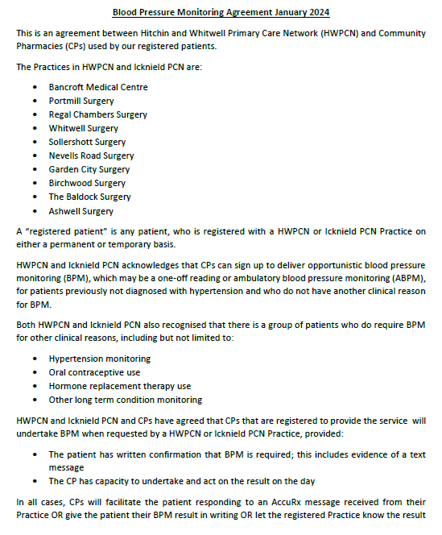

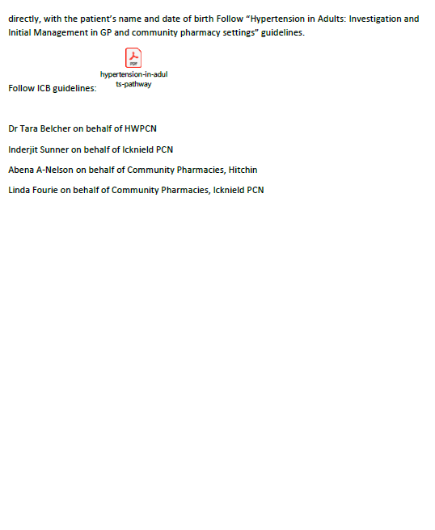

Appendix 3
Four-week SMR (Structured Medication Review) audit trial, running from 2nd to 29th June 2025, to strengthen how pharmacies respond to SMR information shared by GP surgeries — particularly in the context of patients living with frailty and those at risk due to polypharmacy.
Surgeries have been sending SMR updates to pharmacies via Accumail, but we noticed that responses haven’t always been consistent, and there’s little audit evidence to show what’s being actioned. To help with this, we have introduced two simple, GDPR-compliant templates:
- One for pharmacies to record when SMR emails are received and what actions have been taken.
- One for surgeries to track what they have sent and whether a response was received.
These tools are straightforward and quick to complete. The aim is to demonstrate the role pharmacies play in medicines optimisation and safer prescribing, and to provide some clear evidence to share with the ICB at the end of the trial.
To support pharmacy engagement, I have also asked surgeries to highlight any NMS opportunities or potential for hypertension case finding services, and any other applicable services when sending SMR emails. This has helped make the process more relevant for pharmacy teams by linking it to core services.
Both templates are attached – please feel free to adapt or trial them locally if you feel they would be of benefit. I’m happy to share our results and any feedback once the trial concludes.
Thanks,
Roshan Patel
Community Pharmacy Integration Lead - Hatfield & Welwyn PCN

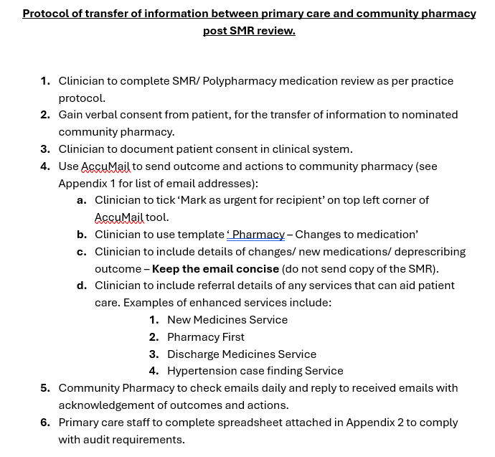

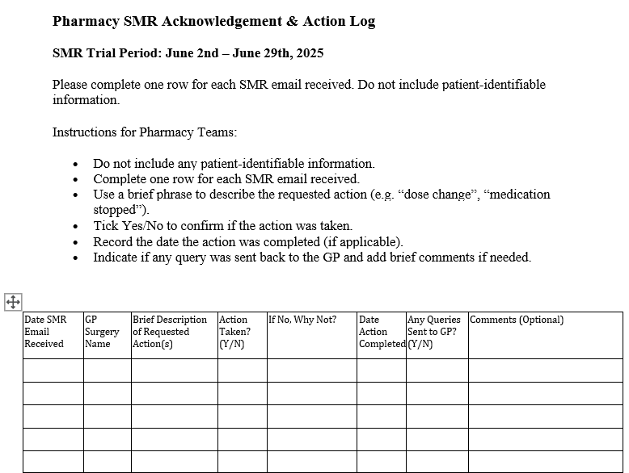
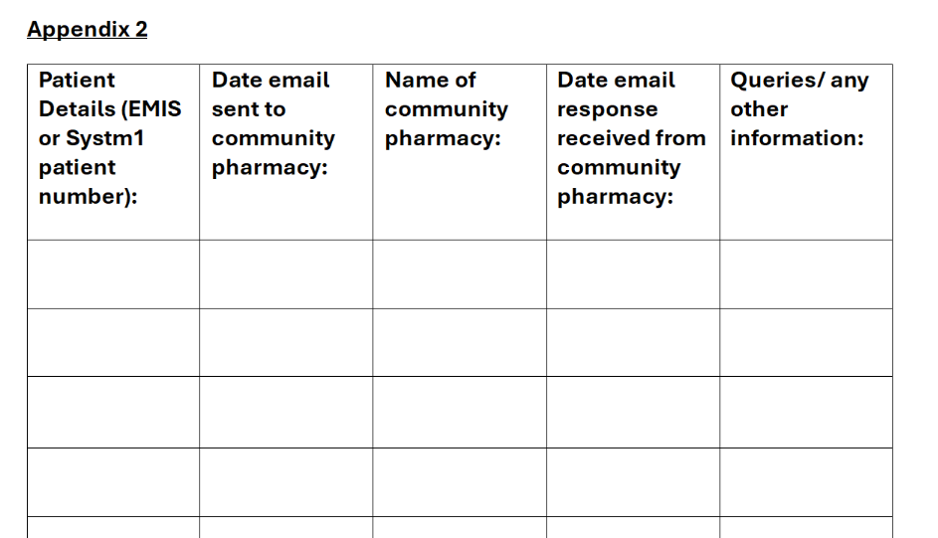

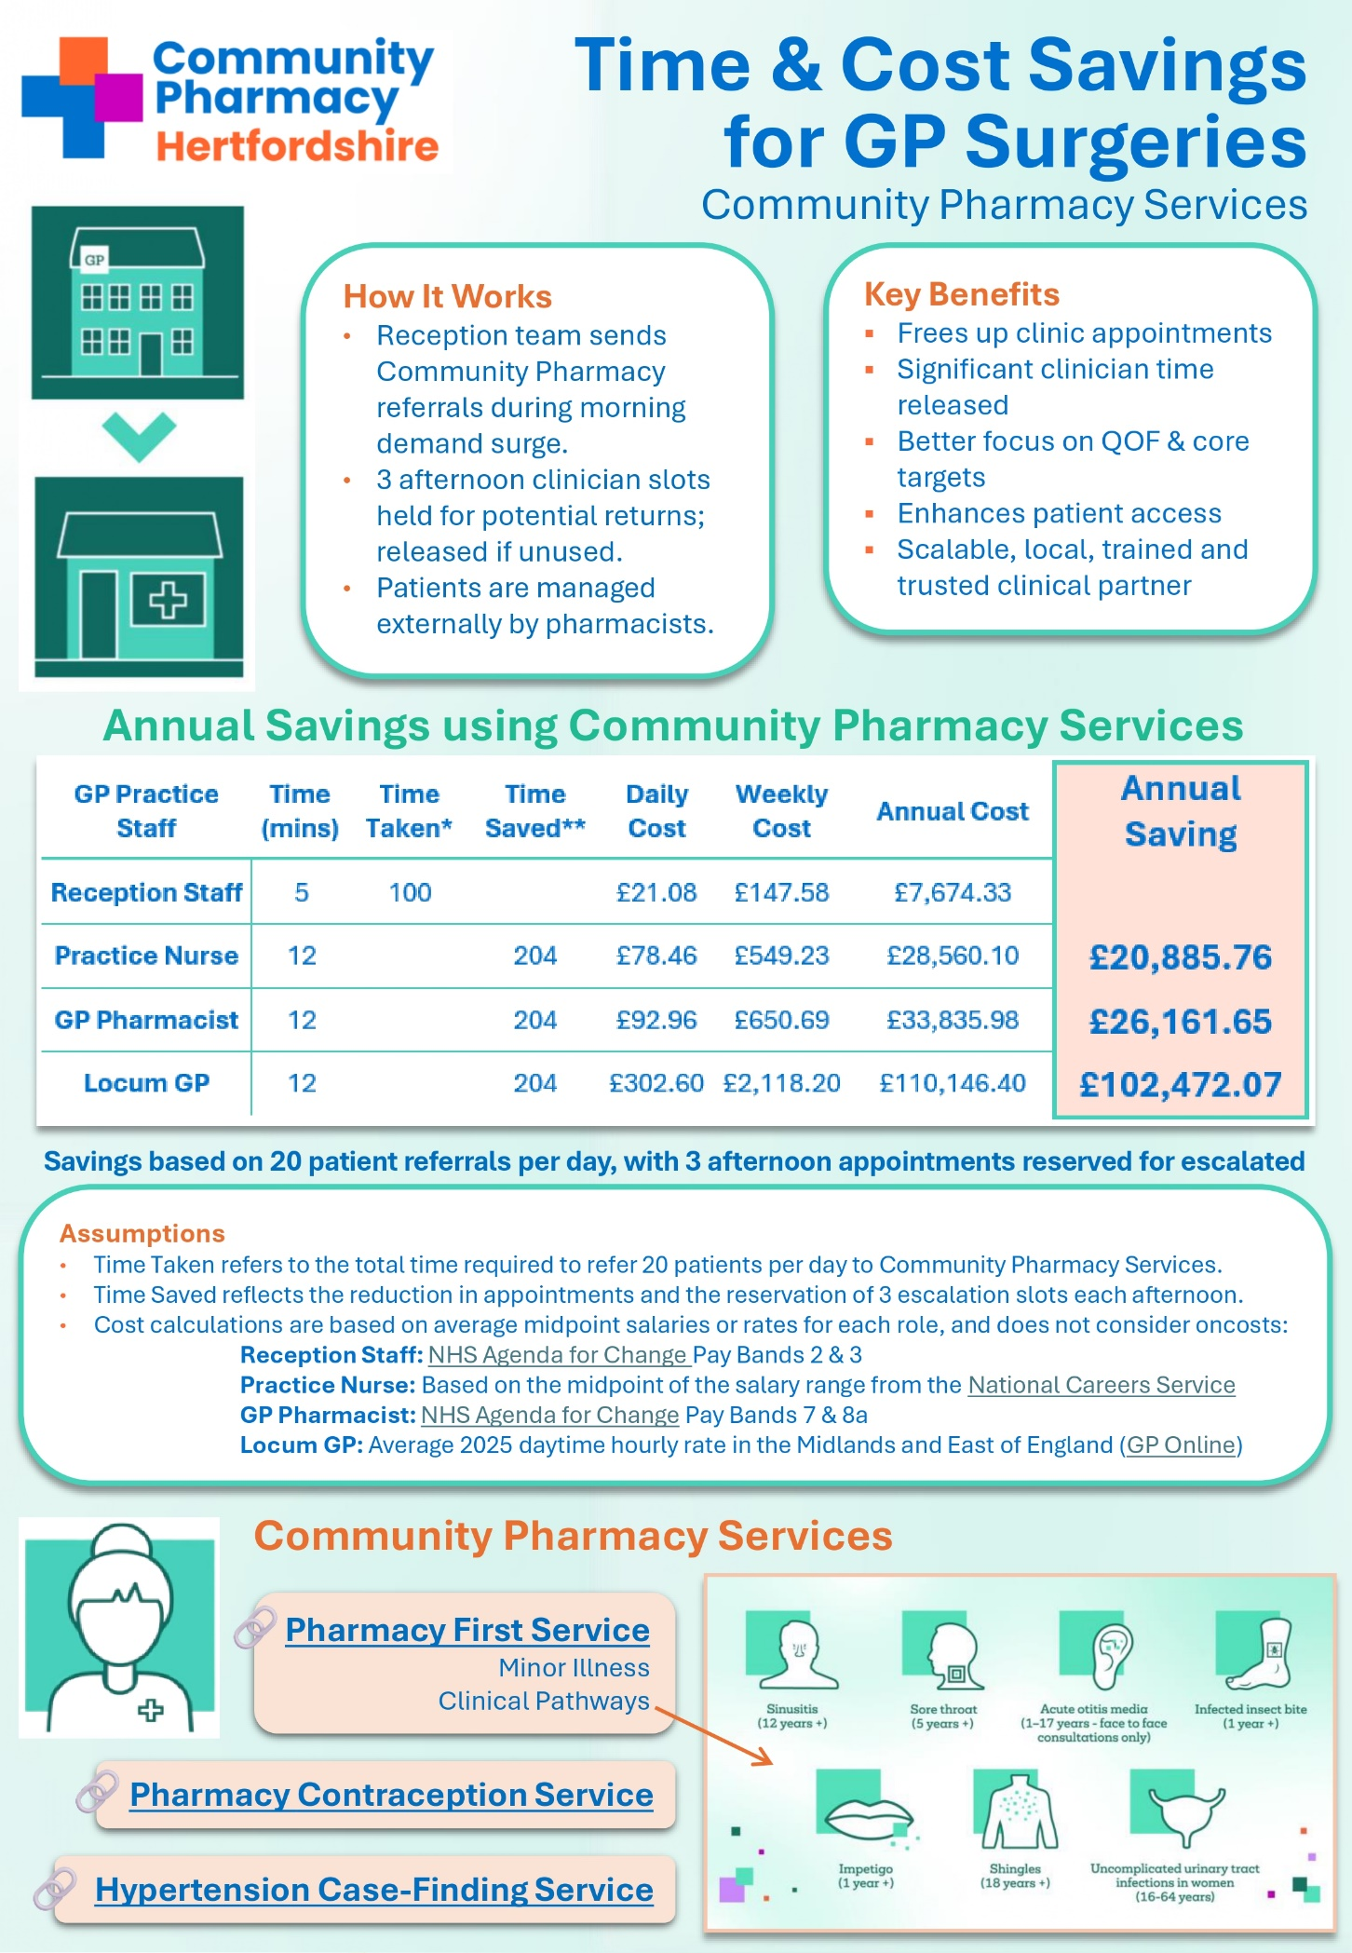
Appendix 4
Appendix 5
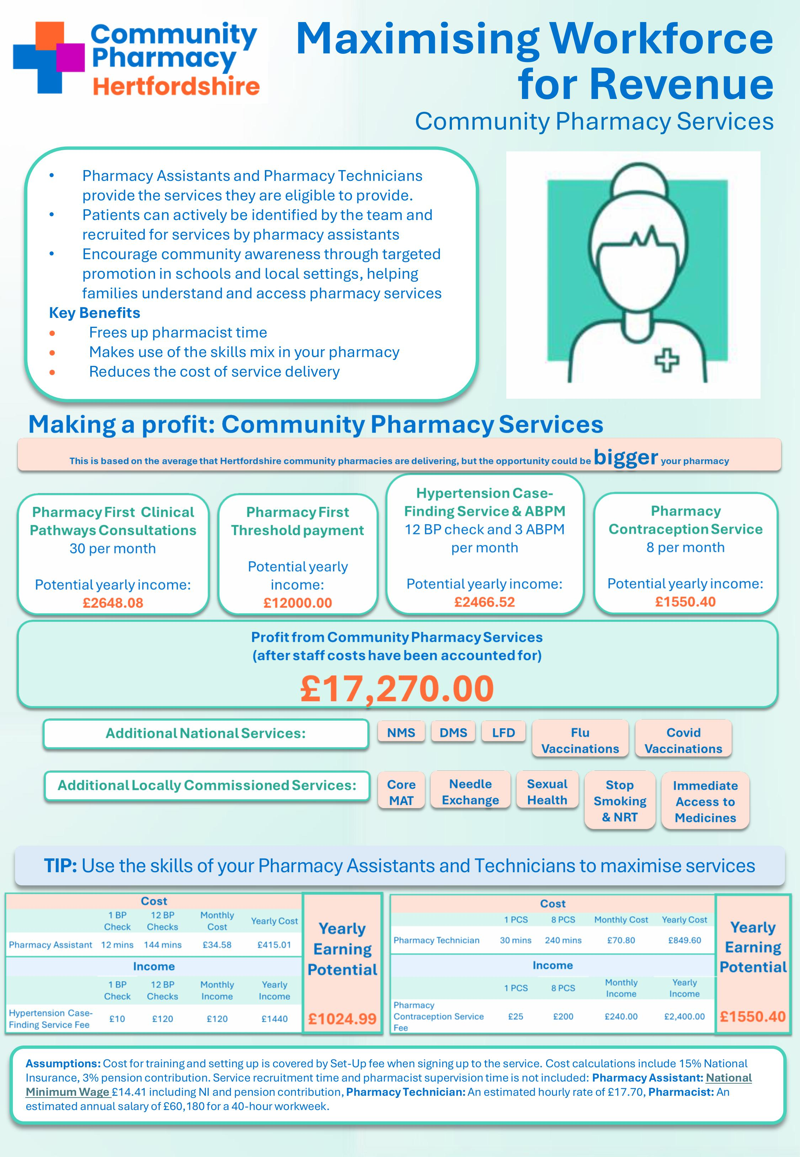
Appendix 6
