Vaccine Supply and Ordering Guidance for Providers
4CMenB (Bexsero) Vaccination Service 2026/27
Contents
Vaccine Supply and Ordering Guidance for Providers 1
Overview 3
Allocations and Ordering 3
Before you can order 3
Step 1 – Register for the service 3
Step 2 – List appointments on the National Booking Service (NBS) 3
Step 3 – Complete the site acknowledgement page in FDP 4
Step 4 – Receive your first allocation and place your order 4
Fixed delivery days and order deadlines 4
Checking Estimated Times of Arrival (ETAs) 5
Deliveries and receipt of vaccine 6
Subsequent allocations and orders 6
Additional supply requests 7
Stocktakes 7
Cold chain and storage 8
Consumables 8
Escalations 8
Risk of Supply Suspension or Withdrawal 8
Key dates summary 8
What is Different to COVID-19 Vaccination Programme 9
Allocation model 9
Ordering Flexibility and delivery dates 9
Order cut-off deadlines 9
Triggering a new allocation 9
Consumables 9
Additional supply requests 10
Stocktake requirements 10
Key Similarities 10
Glossary 10

Overview
The 4CMenB (Bexsero) vaccine used in this service is centrally supplied and free of charge. It must be ordered through the Federated Data Platform (FDP). You will not be reimbursed for vaccine costs as part of this service.
This guidance explains how vaccine will be allocated, ordered and delivered to providers during the MenB vaccination programme. It covers:
- How your vaccine allocation is calculated and increased.
- How to set up NBS appointments and complete the FDP site acknowledgement page.
- How to place orders and meet delivery deadlines.
- Your responsibilities for managing stock and minimising waste.
- Key dates and deadlines.
If you have previously delivered the COVID-19 vaccination programme, see the section What is Different to the COVID-19 Programme at the end of this document before reading the detailed instructions.

Allocations and Ordering

Before you can order
You must complete all of the following steps before you can place a vaccine order. These must be completed in order.

Step 1 – Register for the service
Register for the service by 23:59 on 20 July 2026 via the electronic registration declaration. If you wish to start offering NBS appointments from the Service Commencement Date (20 July 2026), you must have registered by 6 July 2026.

Step 2 – List appointments on the National Booking Service (NBS)
You must list a minimum of 100 appointments per month on NBS, available across various times including late afternoons and Saturdays (where applicable). You should not upload appointments before you have registered for the service in Step 1.
To set up your NBS appointments:
- Follow the guidance: 'Manage your Appointments on NBS' on the V&S Futures workspace
- Use NHS England Digital resources:
  - Manage Your Appointments guidance
  - Create appointment availability
Having appointments available on NBS ensures your vaccine order requests are processed quickly and efficiently.

Step 3 – Complete the site acknowledgement page in FDP
You must complete the site acknowledgement page in the Federated Data Platform (FDP). You will not be able to order any vaccine until this step has been completed.

- Log into the FDP Supply Dashboard
- Review and confirm your site details:
  - Site lead contact information
  - Storage capacity
- Update any incorrect information and click 'Accept'

This step verifies that your site details are correct, including your address, and fridge capacity. Your site address determines where the vaccine will be delivered, so it is important that this information is accurate. If you spot any errors, contact your ICB/SVOC immediately.

Bitesize video guides are available:
How to Accept the Site Acknowledgement Page
How to Update Site Storage Capacity

Step 4 – Receive your first allocation and place your order
Once Steps 1 to 3 are complete, you will automatically be allocated 10 doses (1 box) of 4CMenB (Bexsero) vaccine on the FDP Supply Dashboard. You must then actively place an order on FDP to draw down this stock as vaccine will not be dispatched automatically.
Orders are fulfilled on a fixed delivery day schedule. See Fixed Delivery Days and Order Deadlines below to ensure you place your order in time.

Fixed delivery days and order deadlines
Vaccine deliveries operate on a fixed day schedule assigned to your site. There are no off-schedule deliveries under any circumstances, so it is essential that you place your order before your cut-off deadline. If you miss the cut-off, you will not receive a delivery until your next scheduled delivery day, which may be the following week.

Your order cut-off deadline depends on your fixed delivery day:
Fixed Delivery Day | Order Must Be Placed By
Monday | Thursday of the previous week, by 08:00
Tuesday | Friday of the previous week, by 08:00
Wednesday | Monday of the same week, by 08:00
Thursday | Tuesday of the same week, by 08:00
Friday | Wednesday of the same week, by 08:00

There are no exceptions to these deadlines. Plan your ordering carefully to ensure you do not run out of stock between deliveries, particularly during periods of high appointment demand.

Your fixed delivery day will be available for you to view on the FDP Supply Dashboard, along with your site details, your stock and number of vaccinations given. If you are unsure of your delivery day, contact your ICB before placing your first order.

Checking Estimated Times of Arrival (ETAs)
Estimated times of arrival (ETAs) will be available via the Movianto UK (MUK) website Market Place, rather than on the FDP Supply Dashboard.

Step 1: Enter the URL https://marketplace.movianto.com into your browser.
Step 2: You do not need to sign in as an account is not needed, instead navigate to the search bar on the right of the screen
Step 3: Obtain the order number you are querying from the Supply Dashboard in FDP and prefix it with an M, for example order number “11223” would become “M112233”. Paste this in the search bar and select the spyglass button:-
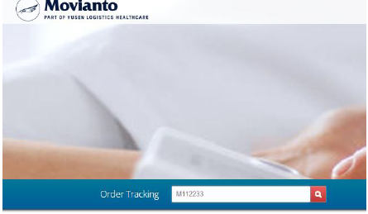

Step 4: You will be shown details of the status of the order, such as its consignment number (prefixed by H00), The post code of delivery, the expected delivery date and time (depending on the status of the order), the history of the order in the warehouse and if applicable the signature of the person who has signed for it:- 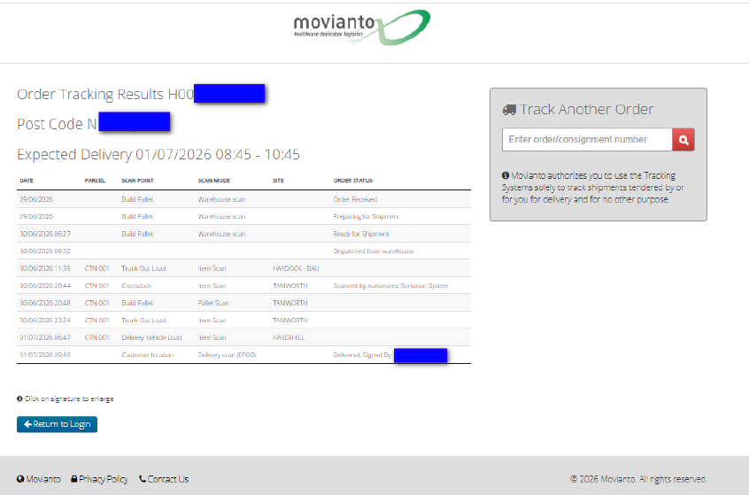
Step 5: If a check on an additional order is required, the search bar is on the right of this screen, you can use this to check further order

Deliveries and receipt of vaccine
The delivery window is between 08:00 and 17:00. The provider must ensure that a trained individual will be available on site to receive the vaccine on the day of delivery, not just during the ETA window in case the delivery is subject to delays. It is not possible for short notice changes (within 72 hours) to be made to the delivery schedules.
If there is a problem with the delivery, then the Lead Contact (on FDP) will be contacted. Changes to Lead Contact details can be made through the FDP Supply Dashboard if necessary.

Subsequent allocations and orders
Once you have used a portion of your initial stock, your allocation will automatically be increased on FDP, when all the following conditions have been met:
- You have recorded use of at least 50% of previously supplied doses (for vaccinations administered before 31 December 2026) or 70% (for vaccinations administered after 31 December 2026); and
- Your current stock is below 1 pack (fewer than 10 pre-filled syringes); and
- Your NBS appointments continue to meet the minimum publication standards; and
- You have submitted a valid stocktake on FDP within the previous 7 days.
Where NBS booked appointments indicate a higher need than the standard 10-dose increase, a larger allocation may be approved.
If these conditions are not met, your allocation will not be automatically increased until you can demonstrate compliance.
When your allocation is increased, it will either be:
- a further 10 doses; or
- a quantity matching your NBS booked appointments, if this indicates a higher need.
You must actively place a new order on FDP to draw down each new allocation as stock will not be dispatched automatically. Orders are fulfilled on your fixed delivery day schedule, so plan ahead to avoid running out of stock between deliveries. This process repeats each time you reach the usage threshold.

Additional supply requests
If your current allocation does not meet your confirmed appointment demand, you can request additional allocation through the FDP Supply Dashboard. Requests will only be approved where there is a clear and evidenced need.
Examples of circumstances where a request may be approved include:
- Confirmed offsite delivery activity approved by the Commissioner
- NBS booked appointments that exceed your current allocation
Requests without clear evidence of additional need will not be approved. This includes requests made solely to cover walk-in activity — walk-ins should be served using surplus stock only.
Providers should ensure their NBS appointments are kept up to date. This is the primary mechanism through which routine allocation increases are identified and applied, and keeping appointments current will reduce the need to make manual requests.

Stocktakes
- You must submit a valid stocktake in FDP within the previous 7 days before you can place any order for additional vaccine.
- Vaccination records must be entered on the same day as administration, unless exceptional circumstances apply.
- Do not stockpile vaccine. All stock must be actively managed.
Failure to report usage or stock levels accurately may result in the temporary suspension of your vaccine supply.

Cold chain and storage
- Vaccines must be stored, handled and transported in line with the manufacturer's instructions, MHRA and UKHSA guidance, and Green Book Chapter 3 ('Storage, distribution and disposal of vaccines').
- Vaccines may only be stored overnight at CQC/GPhC registered premises.
- All vaccine refrigerators must have a maximum/minimum thermometer. Temperatures must be recorded on every working day, with prompt action taken if readings fall outside the recommended range.
- Where vaccination is carried out off-premises, you must ensure cold chain integrity is maintained throughout transport and administration.
- Your SOP must include procedures for cold chain management, including escalation processes for temperature deviations.

Consumables
You are responsible for sourcing and supplying your own consumables, including suitable needles for use with the pre-filled syringes. These are not centrally supplied.

Escalations
If you have any queries regarding how to order vaccine, allocations, stocktakes or deliveries, please escalate to your ICB/SVOC in the first instance, using the escalation template.

Risk of Supply Suspension or Withdrawal
The Commissioner may pause or withdraw your vaccine supply if you:
- Consistently fail to meet the usage thresholds (50%/70% as above); or
- Repeatedly fail to meet the 7-day stocktake reporting requirement; or
- Administer fewer than 10 vaccines between 20 July and 30 September 2026.

Key dates summary
Date | Action Required
6 July 2026 | Register by this date to access NBS from Service Commencement Date
20 July 2026 | Latest registration deadline (23:59)
20 July – 30 September 2026 | Must administer at least 10 vaccines
31 December 2026 | First dose must be administered by this date
31 March 2027 | Service end date

What is Different to COVID-19 Vaccination Programme

Allocation model
There is no season forecast model. All providers start with a flat initial allocation of 10 doses regardless of size or historical activity. Subsequent allocations are either a further 10 doses or a quantity matching NBS booked appointments. The programme is designed for a specific, time-limited cohort of approximately one million young people, so allocations are tightly managed and linked directly to appointment activity. Walk-in activity can be served using surplus stock only. Providers will not receive allocations to cover walk-in activity, and additional supply requests made solely for this purpose will not be approved.

Ordering Flexibility and delivery dates
Unlike COVID-19, providers can only place orders for delivery on their assigned fixed delivery day each week. There are no off-schedule deliveries under any circumstances.

Order cut-off deadlines
Cut-off deadlines are fixed and tied to your delivery day. See the Fixed Delivery Days and Order Deadlines section above for the full schedule. Missing the cut-off means waiting until your next scheduled delivery day. There are no exceptions.

Triggering a new allocation
There is no TDM or season forecast release mechanism. A new allocation is triggered once a provider has vaccinated at least 5 patients (50% of the initial 10-dose pack).

Consumables
Unlike the COVID-19 programme, consumables including suitable needles are not centrally supplied. You are responsible for sourcing and funding your own consumables.

Additional supply requests
Unlike the COVID-19 programme, there is no formal additional supply request process linked to a season forecast. Allocation increases are primarily driven by NBS appointment data and usage thresholds.
However, providers can request additional vaccine supply above their current allocation through the FDP Supply Dashboard where there is a clear and evidenced need. Examples of circumstances where a request may be approved include confirmed offsite delivery activity approved by the Commissioner, or NBS booked appointments that exceed your current allocation. Requests made solely to cover walk-in activity will not be approved.
See the Additional supply requests section above for full details.

Stocktake requirements
Both programmes require a valid stocktake to have been completed within the last 7 days before an order can be placed. The same exceptions apply: no stocktake is required for new sites that have never received stock, or where the last stocktake showed zero stock with no deliveries since.

Key Similarities
The following aspects work in the same way as the COVID-19 programme:
- Vaccine is centrally supplied and free of charge via FDP.
- Providers must actively place orders — stock is not dispatched automatically.
- Stocktake compliance is required before ordering.
- Cold chain management and Green Book Chapter 3 guidance applies.
- Vaccination records must be entered on the same day as administration.
- NBS is used for appointment booking and visibility.

Glossary
Term | Definition
4CMenB | Four-component protein-based meningococcal B vaccine. The vaccine used in this service, supplied as single pre-filled syringes in packs of 10.
Allocation | The quantity of vaccine made available to your site on FDP that you are permitted to order. Your allocation must be drawn down by placing an order — it is not dispatched automatically.
Cold chain | The system of temperature-controlled storage and transportation that maintains vaccine integrity from manufacture to administration.
FDP | Federated Data Platform. The system through which vaccine allocations are managed and orders are placed.
ICB | Integrated Care Board. Your local NHS commissioning body, and your first point of contact for queries and escalation.
NBS | National Booking Service. The system through which patients book their vaccination appointments.
MHRA | Medicines and Healthcare products Regulatory Agency. The UK body responsible for regulating medicines and medical devices.
NBS | National Booking Service. The system through which patients book their vaccination appointments.
Stocktake | A record of your current vaccine stock submitted through FDP. Must be completed within the previous 7 days before placing an order.
SVOC | System Vaccination Operations Centre.
TDM | Targeted Deployment Model. A mechanism used in the COVID-19 programme to automatically increase provider allocations based on booking activity. This does not apply to the MenB programme.
UKHSA | UK Health Security Agency. The government agency responsible for protecting the public from infectious diseases, including oversight of national vaccination programmes.

