Guide to PharmOutcomes
for the
Change Grow Live Core MAT Service

v1.1 February 2024
Welcome to the PharmOutcomes Guide for the Change Grow Live Core MAT service.

Accurate and complete data collection and recording relating to the Core MAT service is vital to ensure the entire healthcare team looking after the individual has access to the same up-to-date information.
Interoperability of PharmOutcomes with Change Grow Live systems means that information recorded by community pharmacies providing the Core MAT Service will integrate directly into the service user clinical record. This will drive the quality of care and treatment provided and enable us to identify and action more targeted support which the individual person needs as part of their treatment and recovery journey.
By utilising PharmOutcomes for data collection and communication between Change Grow Live services and pharmacies, this streamlines the way we work together and helps us to do things better.
Please use this guide to help you with capturing the important information we need to best support the people who use our services.

Registration for all CGL MAT clients
Please ensure you are enrolled as a practitioner before entering any data.
- Enter the name or registration number of the practitioner providing the service and select the correct option from the list.
  - If practitioner registration is required, select the “new practitioner” option, and complete the required steps.
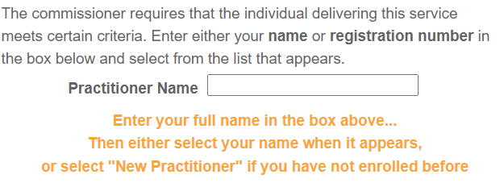

- The registration date box will auto-populate with today’s date. An alternative date can be selected using the dropdown calendar if needed.
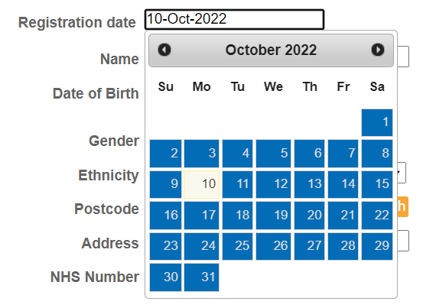
- Search for the person via the Personal Demographic Service (PDS) by entering either the requested personal details, or their date of birth and NHS number:
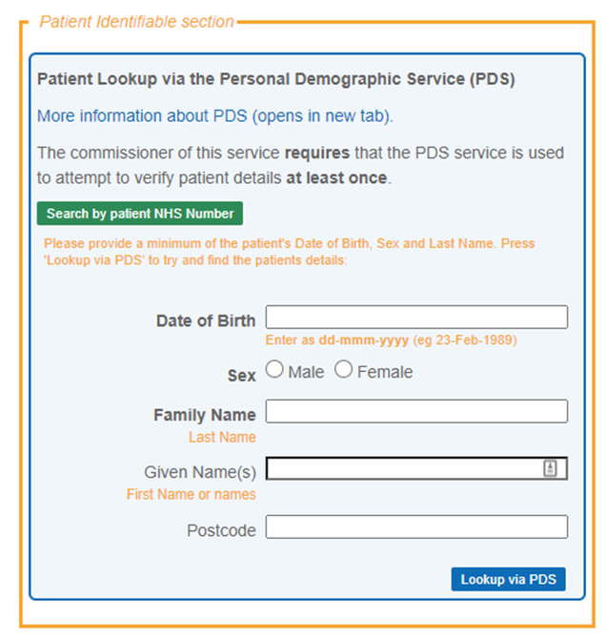
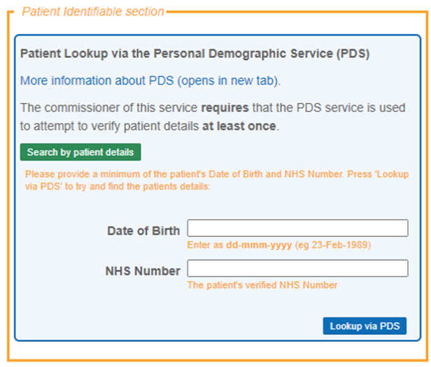

- Once the persons details are entered, click the “Lookup via PDS” button. The persons details will be populated. Confirm the correct person has been identified by clicking “Confirm patient.”
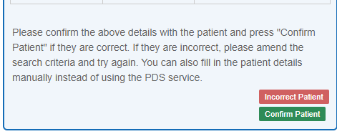

- Where known, record the name of the service users keyworker so a named contact is identified.
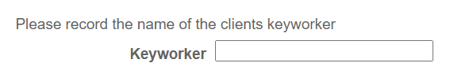
- Save the completed entry to complete the registration process.
CGL MAT – Missed or late collection
Please ensure you are enrolled as a practitioner and the service user has been registered on PharmOutcomes before entering any data.
This is to be completed for everyone receiving MAT treatment who collects a dose late or misses a dose. This information must be recorded accurately for every instance on PharmOutcomes:
- to allow the prescribing service to intervene and provide support to the individual at critical times in their treatment.
- to ensure we have up-to-date information about the persons adherence to their medication which helps to inform their treatment plan, manage risk, and improve the care we provide.
- within 1 working day of the late or missed dose.
Please note: the need to report activity relating to individual supervised doses for each day has been removed.
When 3 doses have been missed consecutively, no further doses should be dispensed. The prescribing service should be contacted for medication to be restarted.
If a service user is on a titration prescription which specifies to contact the prescriber if a titration dose is missed, please ensure this is actioned before supplying the next dose.

- Enter the name or registration number of the practitioner providing the service and select the correct option from the list.
  - If practitioner registration is required, select the “new practitioner” option, and complete the required steps.

- The reporting date box will auto-populate with today’s date. An alternative date can be selected using the dropdown calendar if needed.

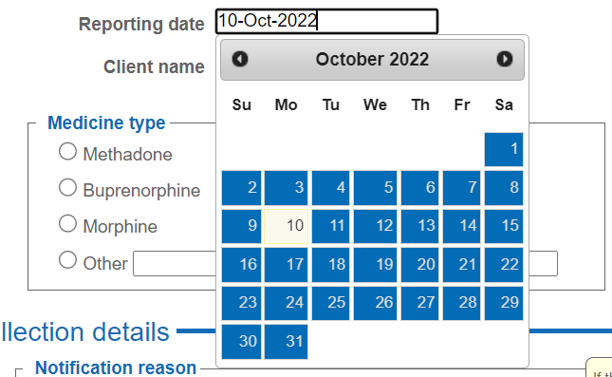

- Search for the service user’s name and select the correct name and date of birth from the options listed.



- Select the name of the medication on the prescription in the “Medicines type” box.
  - For methadone or buprenorphine, select the correct formulation from the sub-menu options.

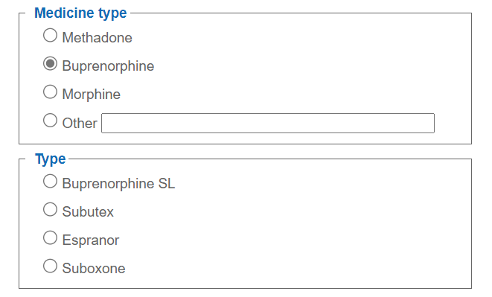
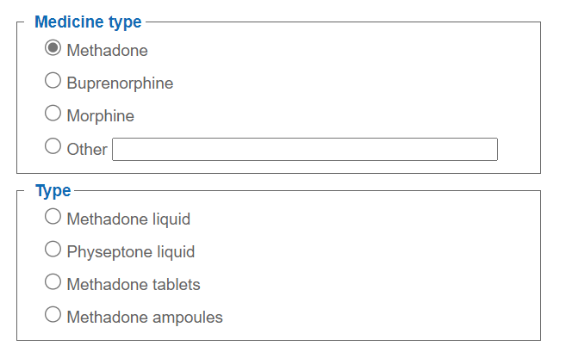

  - For “other” medication, enter details of the medication name and formulation into the box.
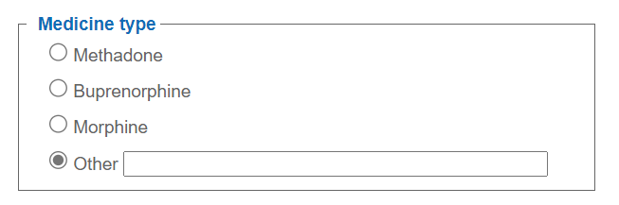
- Select whether the collection instance you are reporting is a missed dose or was collected on a date later than that intended.
- For a missed collection, click the “date of missed collection” box and select the date when the dose was missed on the dropdown calendar.
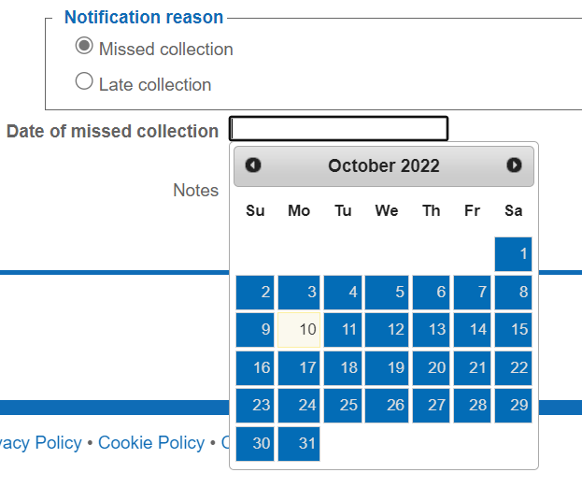
- For a late collection, click the “date of late collection” box and select the date when the late dose was collected on the dropdown calendar.
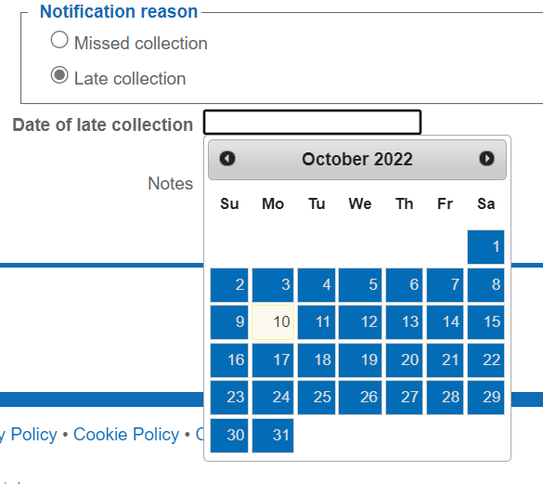

- Where a service user has missed three consecutive days of their MAT medication or a single dose of their titration prescription. Please acknowledge the declaration of a three-day miss or single titration dose missed collection by ticking the box.
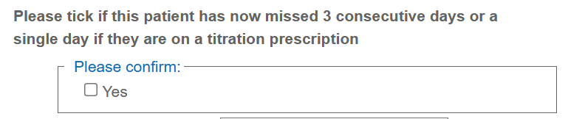

- Please make any relevant notes in the box provided, for example if a reason was provided for the late or missed dose, or if there are any observed patterns relating to dose collection. Any concerns relating to safeguarding should be reported to the prescribing service immediately.

- Save the completed entry to complete the missed or late dose record.

CGL monthly supervised/unsupervised dispensing
Please ensure you are enrolled as a practitioner and the service user has been registered on PharmOutcomes before entering any data.
This service should be completed once dispensing for the month has finished.
- Enter the name or registration number of the practitioner providing the service and select the correct option from the list.
  - If practitioner registration is required, select the “new practitioner” option, and complete the required steps.
- The provision date box will auto-populate with today’s date. An alternative date can be selected using the dropdown calendar if needed. We provide a three month grace period for any unclaimed amounts inclusive of the current month .
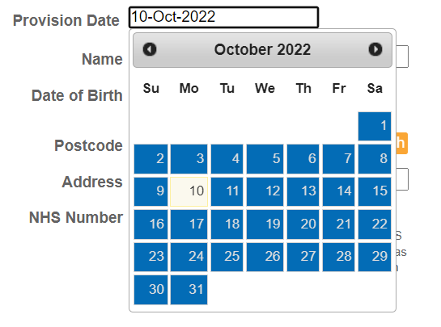
- Search for the person via the Personal Demographic Service (PDS) by entering either the requested personal details, or their date of birth and NHS number:

- Select the name of the medication on the prescription in the “Medicines type” box.
  - For methadone or buprenorphine, select the correct formulation from the sub-menu options.

  - For “other” medication, enter details of the medication name and formulation into the box.
- Select the month of dispensing and/or supervised consumption to which the record relates using the dropdown menu:
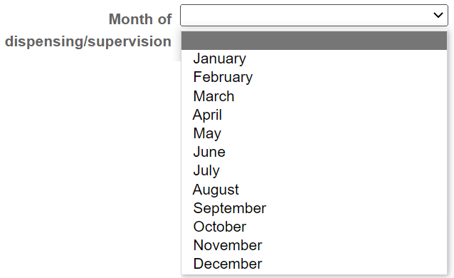

- Select whether supervised consumption has been provided or not at any time during the month:

  - If supervised consumption has been provided, enter the number of doses which have been supervised this month. (Note: each instance of supervised consumption attracts an activity fee)
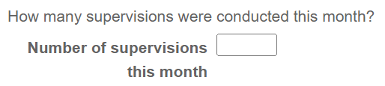

- Confirm that all missed doses or late collections have been reported using the “CGL MAT – Missed or late collection” service on PharmOutcomes.
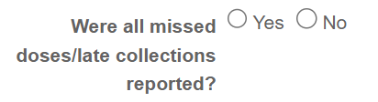

  - If ‘No’ is selected, a message will be displayed to remind you to ensure all missed doses and late collections are reported using the “CGL MAT – Missed or late collection” service on PharmOutcomes.
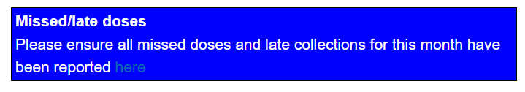

- Select the correct option to record whether 10 or more days medication has been dispensed to this service user this month. (Note: all instances of dispensing medication to cover at least 10 days attracts the monthly fee)


- Save the completed entry to complete the monthly dispensing record.

- If there has been a drug change within the month, please submit a separate claim for each drug.

- Only one monthly claim should be submitted per patient for each drug they are prescribed.
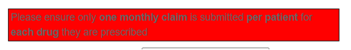

Annual Pharmacist Review
Please ensure you are enrolled as a practitioner and the service user has been registered on PharmOutcomes before entering any data.
- Enter the name or registration number of the practitioner providing the service and select the correct option from the list.
  - If practitioner registration is required, select the “new practitioner” option, and complete the required steps.
- The provision date box will auto-populate with today’s date. An alternative date can be selected using the dropdown calendar if needed.

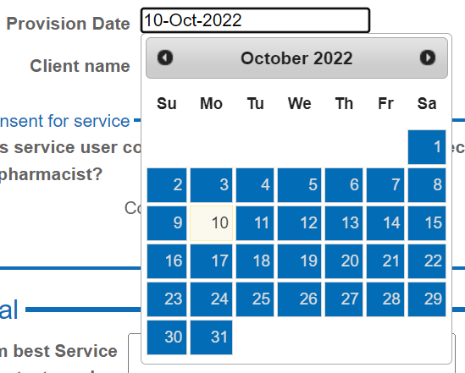

- Search for the service user’s name and select the correct name and date of birth from the options listed.
- Ask the service user for consent to conduct the Annual Pharmacist Review. Record whether consent is given or not given.
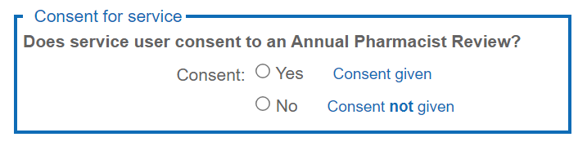

  - If consent is not given, end the review process and complete the service to record that an Annual Pharmacist Review was attempted.


- If consent is given to conduct the review, then gain consent to share data for the information obtained during the Annual Pharmacist Review to be passed to CGL. Record whether consent is given or not.
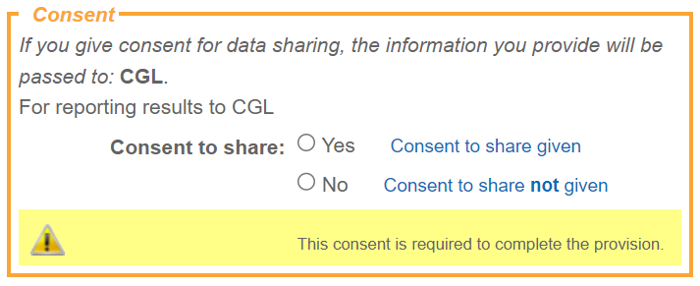

- If consent is given to share data with CGL, proceed with the Annual Pharmacist Review.
- If consent is not given, end the review process and complete the service to record that an Annual Pharmacist Review was attempted.

Conducting the Annual Pharmacist Review

- Ask the service user for consent to access their NHS Summary Care Record. A link will appear for you to access the SCR if the service user gives consent. (This may help you to conduct the review) 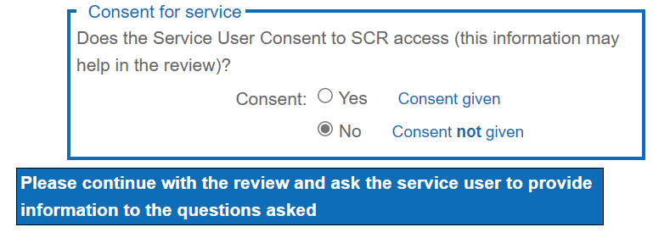

- If the service user declines consent to view their Summary Care Record continue with the review and ask appropriate questions to gain information on current medication taken, both prescribed and OTC, dosages, and allergies.

- Discuss with the service user if they have any allergies to any medication and select the appropriate response. if they do suffer with allergies please note in the box.
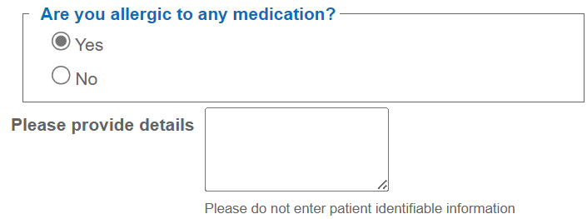

- Discuss with the service user if they have suffered with any adverse drug reactions in the past and select the appropriate response. If they have suffered with any adverse drug reactions, please note in the box.
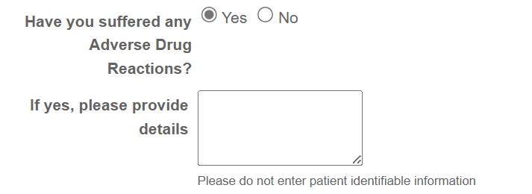

10. Confirm with the service user their current MAT prescribed medication and dosage. Select the drug from the dropdown menu and enter the dose currently being taken.
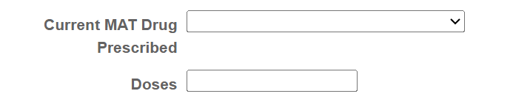

11. Discuss with the service user their adherence to their MAT medication and select the appropriate response. Note how many doses have been missed in the last 28 days. Document if there are any patterns to their missed collections and if there are any reasons for them not being adherent in the note box.
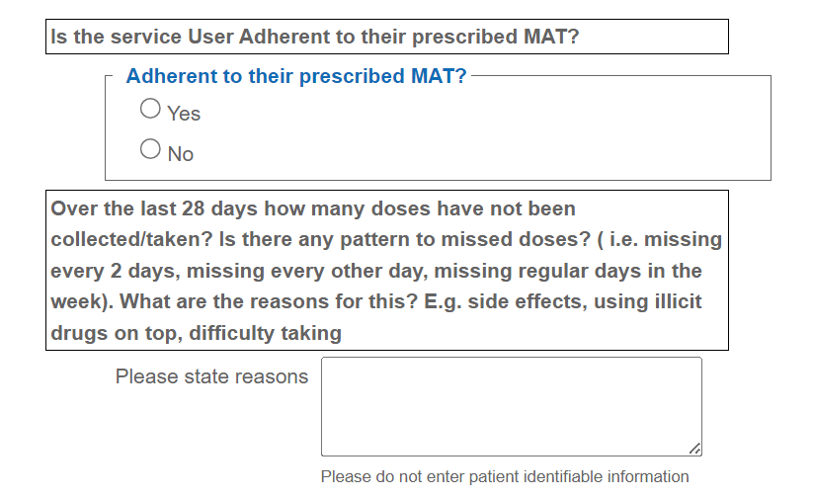
- Discuss with the service user if they would like support to improve their adherence and if so, provide details in the note box. Please include your professional opinion also.
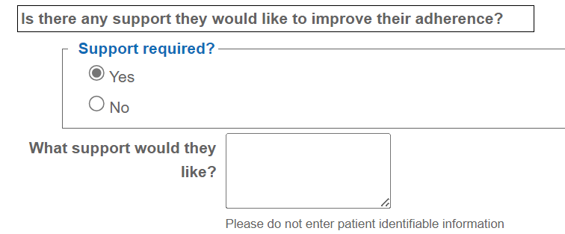

- Check if the service user is on an optimal MAT dose. For Methadone this is between 60-120mg and for buprenorphine (including Espranor) this is between 12-16mg.
If the service user is on a sub-optimal dose, ask the service user if.
a. they are using any illicit drugs on top of their MAT medication or
b. they are stable on a sub-optimal MAT dose/or currently on a planned reducing dose with no illicit drug use.
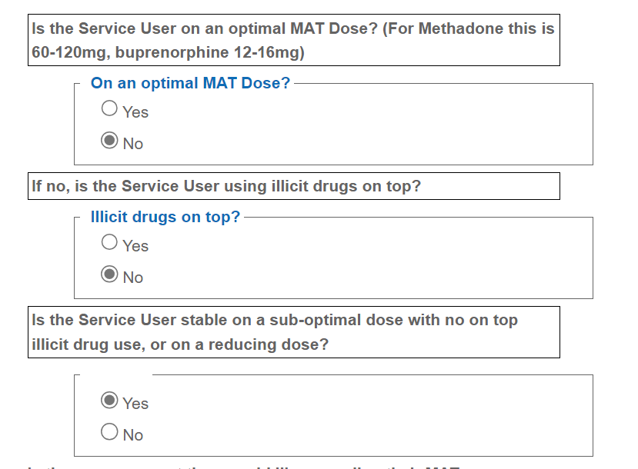
- Using feedback from the service user and your professional opinion, select if there is anything we can do to help support the person with optimising their MAT medication and dose, and if so, provide details in the note box.
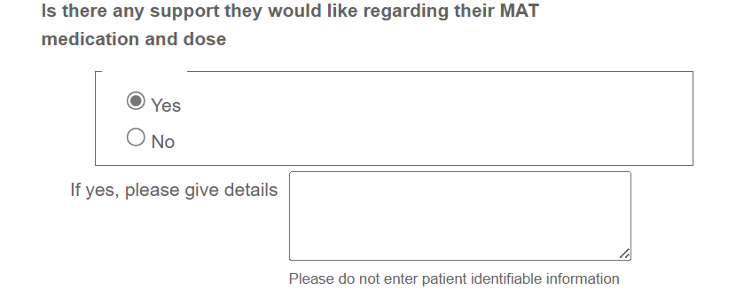

- Check with the service user what other medication they are currently taking. It may be helpful to have access to the Summary Care Record.
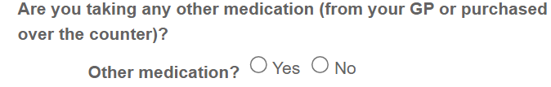
If the service user is not taking any other medication select “No” and continue to the next stage of the review.
If the service user is taking other medication then select “yes” and discuss as described below.
For each medication taken (including OTC):
- Confirm the medication name and dose. Commence typing the drug name and a list should appear to select the required drug and enter the dose.
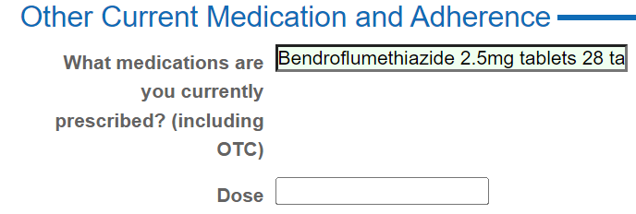
- Check the service users understanding of why they are taking this medication and select the appropriate response. Note the service users understanding of why they are taking this medication in the note box. Where the service user is unsure, provide this information and note in the box. If you provide any other advice regarding the medication e.g. how to take correctly, please also note in the box provided.
- 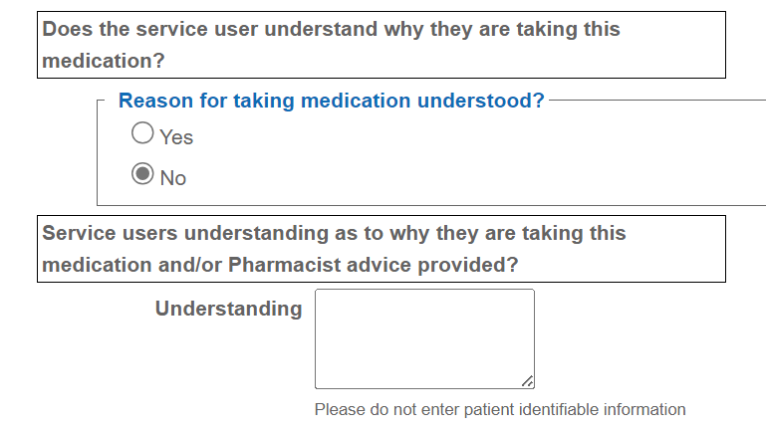
- Discuss with the service user if they are adherent to this medication.
a. If they are not adherent to the medication explore any reasons for this and note in the box provided. If you provide any advice regarding improving adherence also note that in the box.
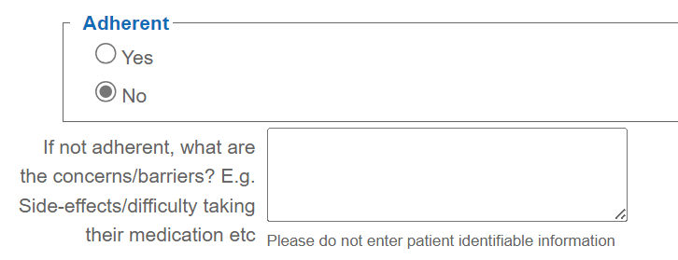
- Repeat this process for each medication they are currently taking.
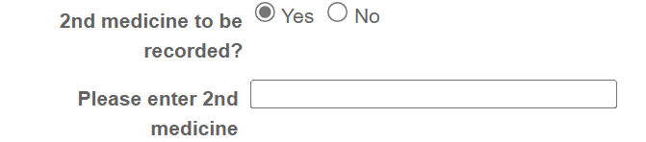

- Having looked at the current medication being taken if in your professional opinion there are any contra-indications, please document in the note box.
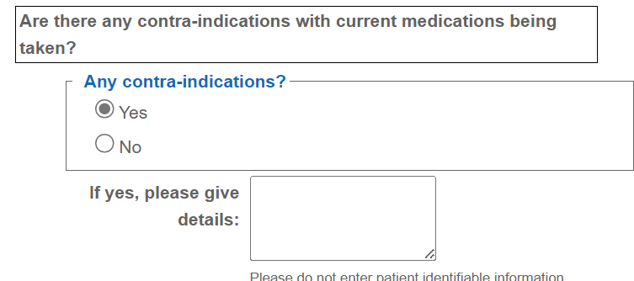

17. In your professional opinion if there are any drug interactions, please document in the note box. This question will only appear if you have selected that the service user is taking other medication in addition to their MAT.
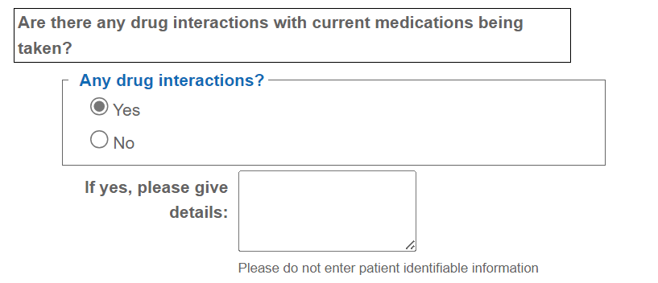

18. If any serious/urgent concerns arise about any prescribed medication these should be communicated directly with the appropriate prescriber.

- Check if the service user has a naloxone kit which is in date, and that they know how to use it.
a. if they have a kit, select “yes”.
b. If they do not have a kit, select “no” and either train and supply in the pharmacy and select “yes” (if commissioned to do so), or if not supplied select “no” and refer to their treatment service or a commissioned pharmacy. Select the appropriate option.
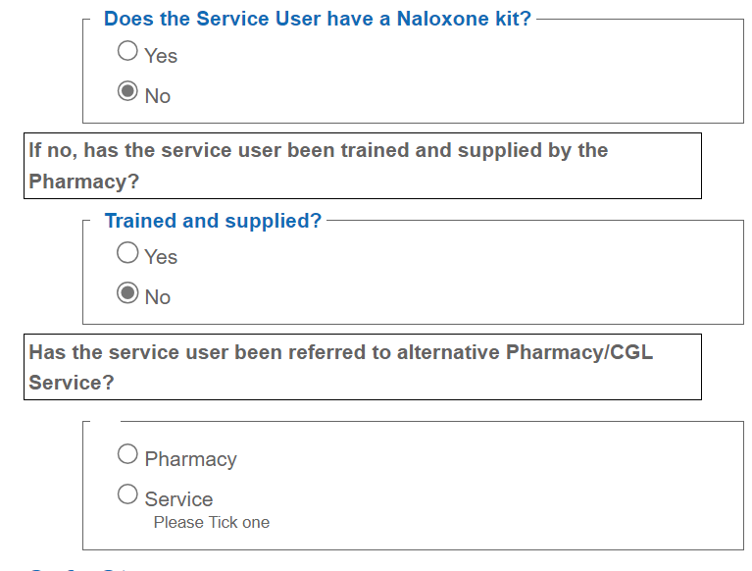
- Check if the service user has a safe storage box to securely store their MAT medication.
a. if the service user has a safe storage box select “yes”
b. If the service user does not have a safe storage box select “no,” please refer them to their CGL Service where a supply can be made and select “yes” in the referral box .
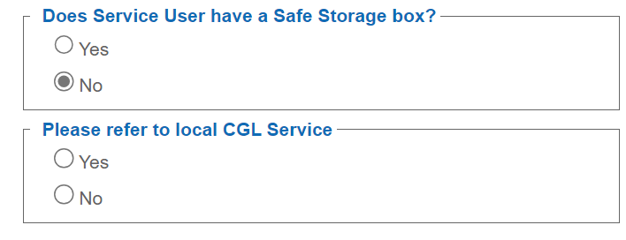
- Where appropriate, discuss lifestyle factors such as smoking status, alcohol consumption, and diet. Select whether a discussion has taken place.
- Document the advice that was given to the service user in the note box.
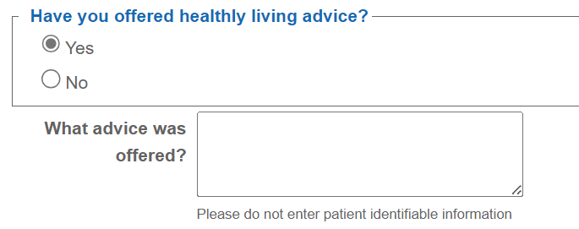
- If required, offer pharmacy services or signpost to services which can support the person with their lifestyle. Select the correct option and add any relevant comments in the note box.
- If not required, select “none of the above” and add any relevant comments.
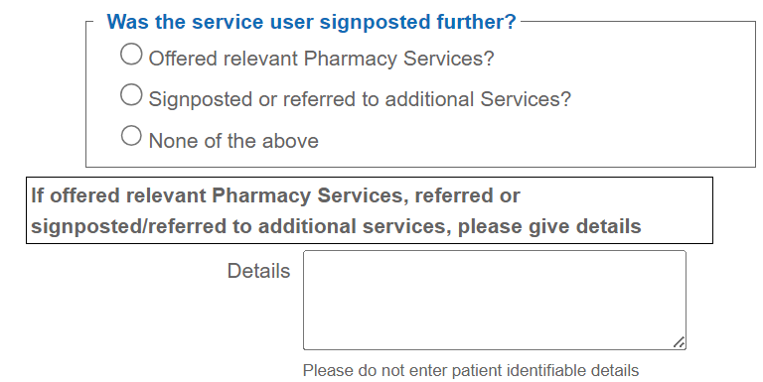

- Give the person the opportunity to discuss anything else.
- If they wish to discuss anything, select “yes,” and record any relevant notes or actions.
- If there is nothing further to discuss, select “no.”
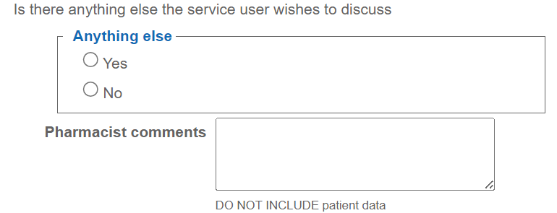
- Save the completed entry to complete the Annual Pharmacist Review record.

- Consider recording completion of the Annual Pharmacist Review on the service users PMR.

